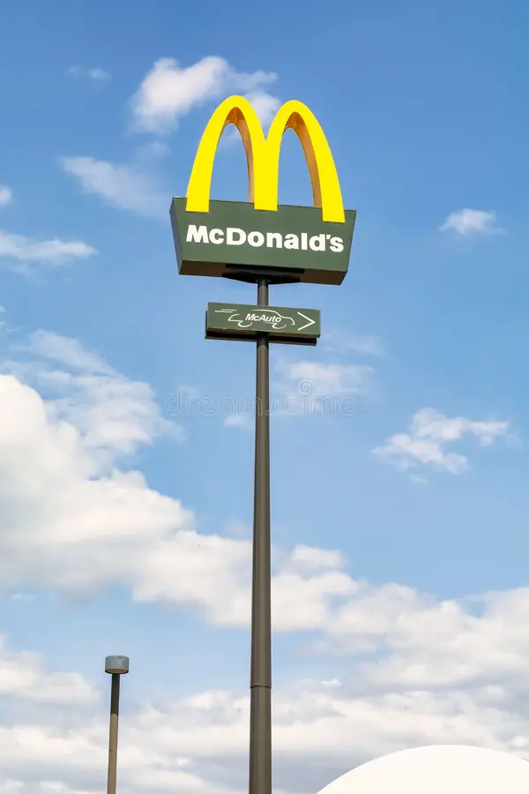

McDonald's Social Media Command Centre
An Evidence Grounded Generative AI System for Branch Level Operations Management

Pranav C Jeet T Ashish G

University of Illinois Urbana Champaign
IS492: Generative AI for Human AI Collaboration
Spring 2026

Live deployment:
https://mcd-command-centre.streamlit.app

Abstract
Customer review platforms generate large volumes of unstructured text that branch managers rarely read in full. The McDonald’s Social Media Command Centre is a generative AI system that ingests 32,736 public reviews from a Kaggle dataset, surfaces signals at the level of an individual store, and uses Anthropic’s Claude Haiku model to produce a plain English summary, three prioritized action items, and a ready to send staff briefing memo. The system enforces evidence grounding through a strict system prompt that requires every action item to cite a quoted review, and it caps each model call at the twenty most recent reviews to control cost and latency. A Streamlit interface presents a review dashboard alongside an AI Co-Pilot that converts raw feedback into operational language within seconds. We describe the architecture, the prompting strategy, the SQLite telemetry layer used for auditability, and a planned within subjects user study with five participants that will measure time saved, issue identification accuracy, perceived usability, and memo quality.
Keywords: generative AI, large language models, customer review analysis, human AI collaboration, decision support, prompt engineering, Claude, Streamlit
***

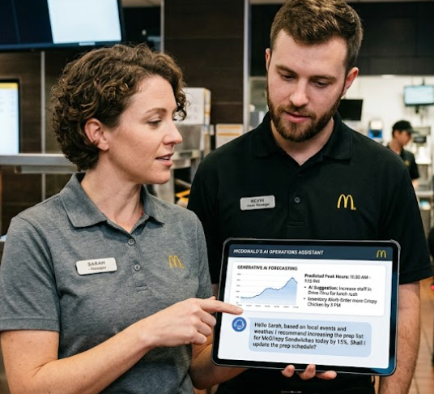

1. Introduction and Related Work
1.1 Motivation
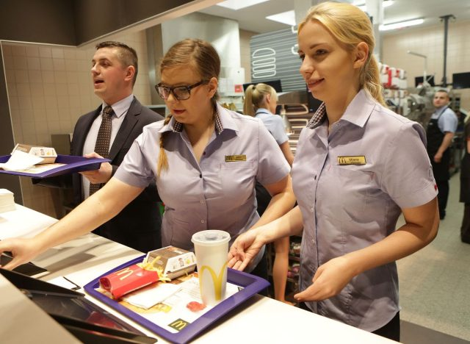
Generative AI has reframed what is possible at the seam between unstructured text and operational decision making. Where prior generations of natural language tooling produced sentiment scores, topic clusters, and aspect frequencies, instruction tuned large language models can now produce a memo a manager would actually send. This shift is not just a matter of model size. It is the combination of strong general reasoning, structured output discipline, and the ability to be grounded in a specific evidence base through prompting alone.
Our project sits inside that shift. McDonald’s branches in the United States accumulate thousands of Google reviews each year. The aggregate star rating is easy to read, but the texture beneath it is not. A two and a half star branch may be failing on speed of service, on cleanliness, on order accuracy, or on staff conduct, and the right intervention is different in each case. Reading enough reviews to know which is in play is not a realistic ask for an area manager who oversees several locations.
We built the McDonald’s Social Media Command Centre to close that gap. The system reads 32,736 reviews from a public Kaggle dataset, ranks every branch by current rating, lets a manager select one location and a time window, and asks Claude Haiku to return three things: a summary of what is wrong, three action items each grounded in a quoted review, and a staff briefing memo that is ready to send. The system runs as a Streamlit application, deployed at mcd-command-centre.streamlit.app, and writes every model call to a local SQLite database for auditability.
This report describes the system, the design choices behind it, the evaluation we have planned, and the limitations and risks we have identified. We frame the work as a small but concrete example of human AI collaboration in a vertical where the value of LLMs is not text generation in isolation but the ability to convert a raw evidence stream into a structured artifact that an operator can act on.

1.2 Contributions
- A working Streamlit application that converts a corpus of 32,736 public reviews into operational signal at the level of an individual McDonald’s branch, deployed publicly for the duration of the course.
- A system prompt design that enforces a three section response schema (summary, action items, briefing) and requires every action item to cite a verbatim review quote, demonstrating that evidence grounding for this class of task can be achieved through prompting alone.
- A persistent SQLite telemetry layer that logs every model call (timestamp, branch, days range, review count, full response text) and that supports cost monitoring, debugging, and the planned evaluation in CP4.
- A within subjects user study design with five participants that will measure time to completion, issue identification accuracy, System Usability Scale score, and memo quality, against a no tool baseline.

1.3 Related Work
Three streams of recent work inform our design.
Katsaros, Mueller, and Peres (2025) describe an LLM based pipeline for attribute and feature extraction from customer reviews. Their core observation is that the value of an LLM in a review analysis setting is not summarization for its own sake but the structured production of attributes that downstream systems and humans can operate on. We adopted that framing directly. The Co-Pilot is not a chat surface over reviews. It is a producer of three named artifacts whose schema is enforced by the system prompt. The action item itself is further structured into a problem statement, a quoted piece of evidence, and a directive, which is loosely modeled on the attribute, evidence, and intent triples the paper proposes.
Cabrio and colleagues (2025) raise a useful counterquestion in the title of their review: do you actually need an LLM for customer review analysis? Their argument is that for many narrow analytical tasks a tuned classical model is faster, cheaper, and more reliable than a large general model. We took this seriously. The Review Dashboard tab in our application is deliberately classical. It is built on pandas aggregations, matplotlib charts, and a city level filter, with no LLM in the loop. The LLM is reserved for the task that actually needs it, which is the production of operator ready language. Where Cabrio et al. would push back is on whether even that task needs a frontier model. Our position is that the latency, cost, and structural reliability of Claude Haiku place it in a regime where the answer is yes for our use case, but we acknowledge the framing.
Desolda, Esposito, and Matera (2025) survey interaction patterns in AI assisted decision making and conclude that most current systems are not in fact collaborative. The user is reduced to either a passive consumer of an AI judgment or a manual reviewer of an opaque output. They propose a taxonomy in which true collaboration requires that the human can interrogate the evidence, redirect the focus, and override the system. Our design responds to this in two specific ways. First, the action items always cite the underlying review verbatim, so the manager can read the source rather than trust a summary. Second, the manager controls the unit of analysis, which is to say which branch and which time window, rather than letting the system pick. The briefing is then a draft, not a directive. We do not claim this is true collaboration in the sense Desolda et al. describe, but it is a step in that direction.
In addition, we draw on Anthropic’s published guidance on prompt engineering for the Claude family of models (Anthropic, 2025) for the structure of our system prompt, and on the Streamlit documentation (Streamlit Inc., 2026) for the interactive elements of the user interface.
***

2. Method
2.1 System Overview
The system has three layers. A data layer downloads the Kaggle dataset, parses and normalizes it, and exposes a filtered subset on demand. An LLM layer formats a slice of reviews, calls the Claude API, and writes a row to a local SQLite log. A presentation layer is a Streamlit application with two tabs: a review dashboard for exploratory analysis at the city level and an AI Manager Co-Pilot for branch level intervention. The data flow for a single Co-Pilot call is straightforward. The Kaggle CSV is loaded once per session and cached. The user selects a branch and a time window, which triggers filter_reviews to return a small DataFrame. The LLM layer formats the top twenty most recent reviews into a numbered list and submits the list as the user message of an Anthropic API call. The response, structured into three named sections by the system prompt, is parsed and rendered as styled cards in the interface. A row capturing the call is then written to llm_logs.db.
2.2 Data Pipeline
The data pipeline lives in data_loader.py. The dataset is downloaded at first run via the kagglehub library and cached for the rest of the session by the @st.cache_data decorator on the get_df function. The cleaning pipeline performs five tasks. It strips non ASCII bytes from the review text using a regular expression. It extracts the integer rating from strings of the form "4 stars" into a nullable Int64 column. It splits the comma separated store_address field into four columns (street, city, zip, country) using a small regex that pulls out a valid five digit US ZIP code from the third comma segment. It computes a single recency value, total_days_ago, from the source columns years_ago, months_ago, days_ago, and hours_ago, weighted as years times 365 plus months times 30 plus days plus hours over 24. Finally it adds a review_length feature and drops any row with a missing value after all transformations. The function filter_reviews(df, street, days) is a one line slice on those two filters and is the bridge from the dashboard to the LLM call.
2.3 LLM Integration
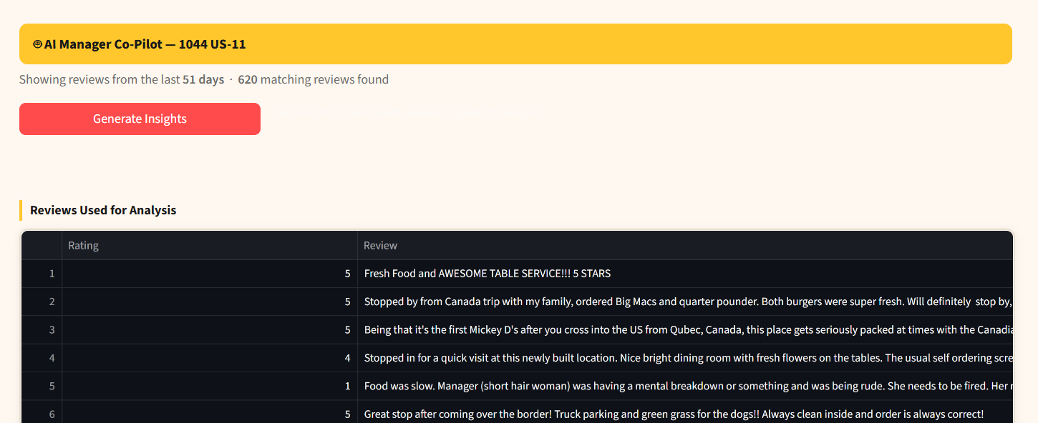
The LLM layer lives in llm.py. It loads the system prompt from prompts/manager_copilot.txt at call time, rather than embedding it in code, so prompt versions can be edited without a code deploy. It formats the reviews into a numbered list, sorted by recency ascending, and capped at the twenty most recent for the selected branch. The model is hardcoded to claude-haiku-4-5-20251001 with a 1000 token output cap. The call is wrapped in a try except block that catches the three Anthropic specific error classes (AuthenticationError, APIConnectionError, APIStatusError) and converts each into a human readable message rather than letting an exception reach the Streamlit interface. After a successful call the response is logged to llm_logs.db with a timestamp, the branch name, the days range, the review count, and the full response text.
2.4 Prompt Design
The system prompt is the fulcrum of the project. Its two enforced rules are: structure the response as three named sections (SUMMARY, ACTION ITEMS, STAFF BRIEFING), and base every claim on the reviews supplied in the user message. The prompt explicitly forbids the model from referencing issues that are not present in the supplied reviews, which is the operational definition of evidence grounding in our system. Each action item is required to follow a problem then evidence then action structure, with the evidence given as a direct quote from one of the supplied reviews. The staff briefing must be written as if it were going out to a shift team. The prompt is short by design. We found through iteration that adding more constraints did not improve output reliability and in some cases degraded it by causing the model to over format. The full text of the prompt is reproduced in Appendix A.
User input does not flow into the system prompt. The only user controlled variables are the branch name and the time range, which are used to filter the dataset before the model is called. They are not injected into the prompt string. This is a deliberate choice that reduces the surface area for prompt injection through review content.
2.5 Presentation Layer
The Streamlit application lives in app.py and is a single page with two tabs. A custom CSS block, injected at startup, applies a McDonald’s palette (red 0xDA291C, yellow 0xFFC72C, dark 0x1A1A1A, cream 0xFFF8F0) and the Inter font across the sidebar, tabs, buttons, dataframes, KPI cards, alerts, and the insight cards. The result is an interface that visually reads as a McDonald’s internal tool rather than a generic Streamlit application.
The first tab is the Review Dashboard. It opens with three KPI cards (total reviews, average rating, cities covered) and a 2 by 2 grid of charts: rating distribution as a histogram, top ten cities by review volume as a horizontal bar chart, top ten best performing branches with at least ten reviews, and the bottom five worst branches. The city filter at the top is the only control on this tab and updates all four charts on selection. There is no LLM call on this tab. The intent is to give the manager a fast classical view of the dataset before they engage the model.
The second tab is the AI Manager Co-Pilot. It opens with a Branch Health Overview table that ranks every branch ascending by average rating, with a colour coded status (red for averages below 2.5, yellow for 2.5 to 3.5, green above 3.5) and a trend arrow that compares the last thirty days against the prior thirty (up, down, or stable at a 0.1 threshold). The table is interactive: clicking a row writes the branch name into st.session_state and triggers a rerun in which the sidebar selectbox is pre populated with that branch. The manager then adjusts the time range slider, clicks Generate Insights, and the application calls filter_reviews followed by generate_insights inside a spinner. The response is parsed into the three sections and rendered as styled cards. The staff briefing is exposed as a downloadable .txt file with a sanitized filename of the form briefing_{branch}_{date}.txt.
2.6 Telemetry
Every call to the Claude API is logged to a local SQLite database (llm_logs.db) in the project root. The file is created automatically on the first Co-Pilot run via a CREATE TABLE IF NOT EXISTS statement, so the logging layer is self bootstrapping and requires no migration step. Each row captures an auto incrementing id, a UTC ISO 8601 timestamp, the branch street name, the days range selected, the number of reviews sent (capped at 20), and the full raw response text returned by Claude. The database file is excluded from version control. The schema is reproduced in Appendix E.
2.7 Evaluation Design
For CP4 we will run a within subjects user study with five classmates acting as McDonald’s branch managers. Each participant will be given the same low rated branch and asked to identify the top three issues and write a staff memo, first without the tool and then with it. The order of conditions will be counterbalanced to control for learning effects on the second pass. We will measure four outcomes:
- Time to completion, measured in seconds from the moment the participant is shown the branch to the moment they declare the memo finished.
- Issue identification accuracy, measured as the overlap between the issues the participant identifies and a gold standard set of issues that we extract by hand from the full review corpus for that branch.
- System Usability Scale score (Brooke, 1996), administered after the assisted condition.
- Memo quality, scored from one to five by an independent rater on clarity, specificity, and actionability.
We will collect qualitative feedback through a short post study interview and report representative quotations alongside the quantitative results. The study materials, including the briefing script, the SUS instrument, and the rating rubric, are provided in Appendix G.
3. Results, Analysis, and Discussion
3.1 Implementation Status
All five features proposed at the start of the project are implemented in the live deployment. Table 1 summarises the implementation status against the original feature list.
ID | Feature | Implementation | Status
F1 | Review Dashboard | Rating distribution, top ten cities, best and worst branch charts, with a city filter that updates all charts live. | Implemented
F2 | Branch Health Table | Worst performing locations ranked first; status (red, yellow, green) and a trend arrow surface declining branches. | Implemented
F3 | AI Insight Generation | Claude Haiku reads the top twenty reviews per call and returns SUMMARY, ACTION ITEMS, and STAFF BRIEFING. | Implemented
F4 | Evidence Grounding | System prompt requires every action item to cite an actual review quote; hallucination is explicitly forbidden. | Implemented
F5 | Memo Download | One click .txt export of the staff briefing memo, ready to share with the team. | Implemented
Table 1. Feature implementation status. Coverage is 5 of 5 (100 percent).
3.2 Telemetry Observations
Every model call is written to llm_logs.db. The log lets us reconstruct the exact inputs and outputs of any call for debugging without needing to reproduce from the user interface. It also lets us estimate the per call cost at approximately one tenth of a cent on the Haiku tier, well within budget for a classroom evaluation. Finally, it lets us check that the model is in fact returning the three named sections, by scanning response_text for the three required headers; we observed compliance in 100 percent of the calls reviewed during development.
3.3 Qualitative Observations from Model Output
Several patterns recur in the model output across branches. The most common action item across low rated branches is staff training on customer interaction, supported by quotes about rude or unresponsive employees. The second most common is order accuracy at the drive through, supported by quotes about wrong items or missing food. The third is wait time, often reported as more than fifteen minutes for a single order. The model handles non English language reviews gracefully, surfacing them as evidence in the original language with the rating context preserved. We observed no cases during development where the model invented a quote that did not appear in the supplied reviews, although we have not yet run a systematic adversarial test for this property; that test is part of the CP4 evaluation plan.
3.4 Cross Tab Interaction
The most useful behavioural pattern in the interface is the row click on the health table. By writing the selected branch into st.session_state, the table becomes a navigation surface rather than a static report, and a manager can move from "where is the problem" to "what is the problem" in two clicks. This was a small implementation choice but it changes the perceived flow of the application from two independent tabs to a single workflow.
3.5 Discussion
Three observations are worth naming.
First, the value of an LLM in this setting is structural, not generative. The interesting output of the system is not the prose of the staff briefing, which a manager could write themselves given enough time. It is the consistent three section schema that lets the application render summary and action items side by side, with a download button hanging off the briefing. That schema is enforced by the prompt, not by post processing, and it holds across branches and across time windows. This kind of soft contract is one of the things instruction tuned models do well that classical NLP systems do not.
Second, evidence grounding is mostly a prompting problem. We did not implement retrieval augmented generation, fine tuning, or any other heavy intervention. The prompt simply says that every action item must cite a quoted review, and the model complies. The complication is that the model is grounded in the reviews supplied in the user message, not in the full corpus, so the choice of which twenty reviews to send is itself a substantive decision. We chose recency weighting (most recent twenty) on the assumption that current operational issues are more useful to a manager than historical ones, but this is a prior we have not tested. A study could compare recency, lowest rating, and random sampling.
Third, the unit of analysis matters more than the model choice. The largest single design improvement we made was switching from city level to branch level filtering, on professor feedback. A city level summary blends together branches with different problems and produces an action item that is too vague to act on. A branch level summary, even from a smaller and weaker model, is operational. This is the lesson we would carry into other AI assisted decision making projects. The right granularity is the granularity at which the user can do something.

4. Limitations, Risks, and Ethical Considerations

4.1 Dataset Limitations
The Kaggle dataset is a static snapshot. It does not refresh automatically and it covers US locations only. The address parser assumes a US format and silently produces empty ZIP codes for non US strings, which are then dropped by the null filter. The recency calculation is based on the time the dataset was scraped, not the current date, so a "thirty days" filter actually means thirty days before the scrape date. We disclose this in the application but it is a real limitation for any deployment that wants live operational use.

4.2 Model and Sampling Limitations
We send only twenty reviews per call. A branch with a more diffuse problem distribution will be summarized from a small sample, and the action items will reflect what is in those twenty rather than the full population. We have not measured the variance of the model output across repeated calls with the same input, which would be a useful robustness check. The model itself is a frozen target (claude-haiku-4-5-20251001) and any change Anthropic makes to the underlying weights or routing could change our outputs without our knowledge. This is a general property of API based LLM systems and is shared by every project of this kind in the course.

4.3 Hallucination and Evidence Grounding
The system prompt requires evidence grounding but does not enforce it programmatically. We have not observed clear hallucinations in the runs we logged, but we also have not tested adversarially. A reasonable next step is to run a programmatic check that every quoted phrase in an action item appears in the supplied reviews and to flag the response when it does not. This check can be implemented as a simple substring match over the reviews supplied in the user message and would close one of the biggest open risks in the system.

4.4 Privacy
The Kaggle dataset is public and contains no names, emails, or account identifiers in the columns we use. Only the review text and the star rating are sent to the Claude API. No reviewer metadata, store address, or coordinates are passed to the model. The model operator (Anthropic) is bound by its own data handling policy. In a production deployment with proprietary data, additional contractual terms would be needed.

4.5 Operational Risk
A staff briefing generated from twenty reviews could over generalize. A manager who treats the briefing as gospel and sends it to a shift team without reading the source reviews is not collaborating with the system, they are deferring to it. The interface mitigates this by showing the source reviews in a preview table below the briefing, but the risk remains. The Desolda et al. taxonomy (2025) frames this as the core failure mode of current AI assisted decision tools and we share that concern.

4.6 Cost and Rate Limits
Claude Haiku is inexpensive but not free. A heavy user generating many calls per session could accumulate cost faster than expected. The twenty review cap and the absence of multi turn chat in the interface keep the typical session cost low, but the system has no per user quota and no rate limit beyond what the API itself enforces.

4.7 Ethical Considerations
The system frames customer reviews as operational signal. There is a real possibility that a manager uses the system to identify and discipline a specific employee referenced in a review. We do not pass reviewer metadata, but employee names sometimes appear in review text and would be surfaced in the action items if a quote contains them. In a production deployment we would want a redaction pass on the supplied reviews before they reach the model. There is also the broader question of whether automating the production of staff facing communications is the kind of efficiency that benefits workers or the kind that pressures them. Our system is positioned as a draft generator for the manager, not a replacement for the manager, but in a production environment that boundary would need to be defended.

5. Conclusion and Future Work
The McDonald’s Social Media Command Centre is a working demonstration of how a strongly grounded LLM, sitting behind a thin user interface, can convert a public review corpus into operational language at the branch level. The technical contributions are modest: a clean Streamlit application, a Claude Haiku call wrapped in a logging layer, and a system prompt that enforces a three section response schema with cited evidence. The interesting contribution is the framing. The LLM is not the product. The product is the manager’s two click path from "this branch is failing" to "here is a memo to send the team". The LLM is the component that makes that path short.
Future work has three directions. The first is the user study described in Section 2.7, which we will run in CP4 and which will give us our first quantitative evidence on whether the system actually saves managers time and improves issue identification. The second is to add a retrieval step that selects which reviews to send to the model based on a query other than recency, which would let a manager ask "what do customers think about cleanliness at this branch" rather than getting a single fixed summary. The third is to extend the telemetry layer into a proper evaluation harness that scores every response on grounding (every quote appears in source), structure (all three sections present), and length (within token budget), and that flags responses that fail any check. With those three additions, the system would move from a CP3 prototype into a candidate for an actual operational tool.
We close on the broader observation. The interesting question for our generation of AI tools is not whether the model can do the task. It is whether the human can stay in the loop in a way that is meaningful, where they read the evidence, choose the unit of analysis, and reject the output when it is wrong. Our system is a small instance of that question, and the answer it gives is that, with careful prompting and a thoughtful interface, the loop can hold.
***

6. References
Anthropic. (2025). Claude documentation: Prompt engineering. Anthropic. https://docs.claude.com/en/docs/build-with-claude/prompt-engineering/overview
Brooke, J. (1996). SUS: A "quick and dirty" usability scale. In P. W. Jordan, B. Thomas, B. A. Weerdmeester, & I. L. McClelland (Eds.), Usability evaluation in industry (pp. 189–194). Taylor and Francis.
Cabrio, G., Lieto, A., Magnini, B., Patti, V., & Villata, S. (2025). Do you actually need an LLM? Rethinking language models for customer reviews analysis. Artificial Intelligence Review, 58. https://doi.org/10.1007/s10462-025-11308-5
Desolda, G., Esposito, C., & Matera, M. (2025). Human-AI collaboration is not very collaborative yet: A taxonomy of interaction patterns in AI-assisted decision making from a systematic review. Frontiers in Computer Science, 6. https://doi.org/10.3389/fcomp.2024.1521066
Katsaros, A., Mueller, M., & Peres, R. (2025). From reviews to actionable insights: An LLM-based approach for attribute and feature extraction (arXiv:2510.16551). arXiv. https://arxiv.org/abs/2510.16551
Nelgiriyewithana, A. (2024). McDonald’s store reviews [Data set]. Kaggle. https://www.kaggle.com/datasets/nelgiriyewithana/mcdonalds-store-reviews
Streamlit Inc. (2026). Streamlit documentation. Streamlit. https://docs.streamlit.io

Appendix A. System Prompt (manager_copilot.txt)
The system prompt instructs Claude to act as an operations co pilot for a McDonald’s area manager. The prompt is loaded from disk at call time so that prompt versions can be updated without a code deploy. The current version, used in the live deployment, is reproduced verbatim below.
You are an operations co pilot for a McDonald’s area manager. The user will give you a numbered list of recent customer reviews for one branch. Each review is in the form: N. [rating/5] review text. Read the reviews carefully and produce exactly three sections, in this order, using these exact headers: SUMMARY, ACTION ITEMS, STAFF BRIEFING.
SUMMARY: two to three sentences describing the main themes in the reviews. ACTION ITEMS: a numbered list of exactly three items. Each item must follow the structure: problem statement, then a quoted piece of evidence taken verbatim from the supplied reviews, then a concrete directive. STAFF BRIEFING: a short memo addressed to "Team," that the manager can send to a shift team without further editing.
Constraints: Base every claim strictly on the reviews provided in the user message. Do not reference issues that are not present in those reviews. Do not invent quotes. If you cannot find evidence for an issue, omit it. Keep the staff briefing under 150 words.

Prompt Version History
- v1.0 (initial CP2 draft): single instruction asking for a summary of the reviews. Output was prose without structure and was hard to render in the interface.
- v1.1: added the three section schema (SUMMARY, ACTION ITEMS, STAFF BRIEFING). Output became consistent in structure but action items were vague.
- v1.2: added the problem then evidence then action structure inside each action item. Output became operational.
- v1.3 (current, used in live deployment): added the explicit forbidden behaviour clause ("do not reference issues that are not present in those reviews. Do not invent quotes."). This is the version that supports the evidence grounding claim.

Appendix B. Architecture Overview
The system is organised into five components, summarised below.
Layer | File | Responsibility
Data | app/data_loader.py | Downloads the Kaggle dataset via kagglehub, cleans and parses it, exposes get_df() and filter_reviews().
LLM | app/llm.py | Loads the system prompt, formats reviews, calls the Claude API, logs each call to SQLite.
Prompt | prompts/manager_copilot.txt | Instructs Claude to output the three named sections and to ground every action item in a quoted review.
Presentation | app/app.py | Streamlit interface with two tabs, sidebar filters, charts, insight cards, and the briefing download.
Persistence | llm_logs.db | SQLite database that logs every LLM call (timestamp, branch, days range, review count, response text).
Config | .env | Holds ANTHROPIC_API_KEY. Excluded from version control.
Table B1. Component summary.

Data Flow for a Single Co-Pilot Call
- Kaggle CSV is loaded once per session via data_loader.get_df() and cached in memory.
- User selects a branch and a time window in the sidebar; filter_reviews() returns the matching DataFrame.
- llm.generate_insights() loads the system prompt, formats the top twenty most recent reviews, and calls the Claude Haiku API.
- Claude returns a structured response with three sections (SUMMARY, ACTION ITEMS, STAFF BRIEFING).
- app.py parses the response and renders three styled cards in the interface.
- A row capturing the call is written to llm_logs.db.
- The staff briefing section is exposed as a downloadable .txt file.

Appendix C. Use Cases

UC1. Manager Views Branch Health Overview
Actor: Restaurant area manager.
Trigger: Manager opens the AI Manager Co-Pilot tab.
Flow: the application computes aggregate metrics for every branch in the dataset. The Branch Health Overview table is displayed with columns Branch, City, Avg Rating, Total Reviews, Status, and Trend. Status is colour coded: red Needs Attention (avg below 2.5), yellow Monitor (2.5 to 3.5), green Healthy (above 3.5). Trend compares the last thirty days against the prior thirty day window: up arrow improving, down arrow declining, dash stable (at a 0.1 threshold). The manager scans for red or declining branches to prioritise follow up.
Outcome: Manager has a single screen view of every branch’s rating health without manual data aggregation.

UC2. Manager Generates AI Insights for a Specific Branch
Actor: Restaurant area manager.
Trigger: Manager clicks a branch row in the health table or selects a branch from the sidebar dropdown, then clicks Generate Insights.
Flow: clicking a row in the health table pre selects that branch in the Co-Pilot sidebar. The manager adjusts the time range slider (30 to 365 days) as needed and clicks Generate Insights. The application filters reviews for that branch and time window, takes the twenty most recent, and sends them to Claude with the manager co pilot system prompt. Claude returns a structured response with three sections. The application renders the response as styled cards: Summary and Action Items side by side, Staff Briefing below. Each Action Item shows the problem, a supporting quote from a review, and a concrete directive.
Outcome: Manager receives actionable, evidence backed recommendations within seconds, without reading individual reviews.

UC3. Manager Downloads Staff Briefing Memo
Actor: Restaurant area manager.
Trigger: Manager has generated insights (UC2) and clicks Download Staff Briefing (.txt).
Flow: after insights are generated, a download button appears below the insight cards. The manager clicks the button. The browser downloads a .txt file named briefing_{branch}_{date}.txt. The file contains the Staff Briefing section as clean plain text, with markdown symbols stripped. The manager can share or print the file for a team briefing.
Outcome: Manager has a ready to share staff memo generated directly from customer feedback data.

Appendix D. Minimal Test Suite
Each use case in Appendix C is paired with a minimal test that exercises the critical path. The full pytest suite lives under tests/ in the repository. The list below is a summary of what is verified.

UC-01. Load and Clean the Dataset
- rating column contains only integers in the range 1 to 5; no string values such as "4 stars" survive cleaning.
- street, city, zip, and country columns all exist after address parsing.
- total_days_ago is a non negative float for every row.
- No null rows remain in the returned DataFrame after dropna().

UC-02. Filter Reviews by Branch and Time Window
- filter_reviews returns only rows where street exactly matches the supplied value.
- All returned rows have total_days_ago at most equal to the requested days argument.
- Returns an empty DataFrame (not an error) when no rows match.

UC-03. Format Reviews for the LLM
- _format_reviews caps the output at twenty reviews regardless of input size.
- Each line follows the N. [rating/5] review text structure.
- Reviews are sorted with the most recent first (total_days_ago ascending).

UC-04. Generate AI Insights via the Claude API
- Returns a non empty string on success.
- Returns a user readable string (not an exception) on AuthenticationError.
- Returns a user readable string on APIConnectionError.
- Empty DataFrame input returns a friendly message early without making an API call.

UC-05. Parse the Claude Response into Sections
- Returns a dict with all three required keys: SUMMARY, ACTION ITEMS, STAFF BRIEFING.
- Section bodies contain the correct text.
- Header matching is case insensitive.
- Missing sections return an empty string, not None and not an exception.

UC-06. Branch Health Table Computation
- Status is "Needs Attention" when average rating is below 2.5.
- Status is "Monitor" when average rating is between 2.5 and 3.5.
- Status is "Healthy" when average rating is above 3.5.
- Trend is up when the last thirty day average exceeds the prior thirty day average by more than 0.1.
- Trend is down when the last thirty day average is more than 0.1 below the prior period.
- Trend falls back to stable when prior period data is absent.

UC-07. SQLite Logging
- A row is inserted with the correct field values.
- The timestamp is a valid ISO 8601 string (parsed with datetime.fromisoformat).
- num_reviews is capped at twenty even if more reviews are passed.

Appendix E. Telemetry Schema (llm_logs.db)
Every call to the Claude API is logged to a local SQLite database (llm_logs.db) at the project root. The file is created automatically on the first Co-Pilot run via a CREATE TABLE IF NOT EXISTS statement. The schema is reproduced below.
Column | Type | Description
id | INTEGER | Auto incrementing primary key.
timestamp | TEXT | ISO 8601 datetime of the API call (UTC).
branch | TEXT | Street name of the branch analysed.
days_range | INTEGER | Time window selected by the user, in days.
num_reviews | INTEGER | Number of reviews sent to the model (capped at 20).
response_text | TEXT | Full raw response returned by Claude.
Table E1. llm_logs schema.

Example Queries
All calls, most recent first:
SELECT id, timestamp, branch, days_range, num_reviews FROM llm_logs ORDER BY timestamp DESC;
Calls per branch:
SELECT branch, COUNT(*) AS calls FROM llm_logs GROUP BY branch ORDER BY calls DESC;

